Report

Using a Yahoo Finance API for fundamental stock analysis

Student Name: Dan MacCarthy
Course: UCD Professional Academy
Certificate in Introductory Data Analytics
Date: 24/03/2021
GitHub repository: DanMacCarthy/UCDPA_DanMacCarthy
GitHub repository filepath: https://github.com/DanMacCarthy/UCDPA_DanMacCarthy.git

1.0 Introduction
Investment in Stock Equities
I have an interest in investment finance, particularly in using the fundamental or ‘intrinsic’ value of a company as a basis for investment decisions. Benjamin Graham is the father of ‘value investing’ and Warren Buffett is the greatest practitioner. Value investing is a bit out of fashion currently, as investors are more attracted to growth stocks.
Having an interest in business and in technology, I am drawn to the US markets such as the technology heavy Nasdaq.
The investment finance domain is data rich in quantitative data, with an overwhelming number of measures of stock performance. I have used a book called Payback Time by Phil Town as a guide to the methodology for determining the value of a stock. Here is a link to his website.
https://www.ruleoneinvesting.com/blog/how-to-invest/payback-time
The Stock market today
We live in interesting times; both the Nasdaq and Standard and Poor Indices have recently hit all time highs. Putting money on bank deposit or buying government bonds will yield a negative return. The stock market is attractive to both institutional and retail investors. A significant amount of investment money is chasing a return on investment. The US FED is supporting the stock market with an aggressive quantitative easing policy. This has led to a strong rally in stock prices, with very high stock valuations. Stock prices have become decoupled from their past earnings and growth estimates. Stock Price to Earnings ratios are at nose-bleed levels.
There are signs of an imminent market correction, (look to the recent drop in Tesla stock)
How to Value a stock
The first step is to determine if the company of interest has a competitive advantage, which is called ‘a moat’. Companies that have been able to sustain compounded annual growth rates of over 10% per year in Earnings per share (EPS), Operating CashFlow per Share (OCPS), Sales growth and Book Value per Share (BVPS) have a durable moat.
The next step is to determine how effectively the management are in producing a return on all the invested capital and on the shareholder’s equity. Return on Invested Capital (ROIC) and Return on Equity (ROE) are the measures used.
Next the amount of debt relative to earnings is measured. We are looking at how long it would take the company to pay off total debt if it used current level of earnings.
The final step is to calculate the intrinsic value of the share, based on current earnings per share, an estimate of future earnings growth rate, a future price-to-earnings multiple, and a user defined minimum acceptable rate of return.
See Appendix 1 – Method for Stock Valuation
Or https://www.ruleoneinvesting.com/investment-calculators/

2.0 Sourcing an API to interface with Yahoo Finance
With the demise of MSN money, Yahoo Finance is now the preeminent website for stock data for non-professional investors. I sourced 3 different APIs for Yahoo Finance
The best of the 3 APIs was Yahooquery
This excellent website demonstrates the use of the Yahoo query package
https://yahooquery-streamlit.herokuapp.com
Here is an article on yahooquery
https://towardsdatascience.com/the-unofficial-yahoo-finance-api-32dcf5d53df

3.0 Data Import using Yahooquery
Pandas was imported using alias pd
The Ticker module from the Yahooquery API was imported.
My strategy was to get the program to work for a single stock ticker first.
I needed to download the annual financial statements (Income Statement, Cashflow Statement, and Balance Sheet) for as many years as Yahoo Finance had the data.
Yahoo Finance had the annual financial statements from 2017 to 2020
Other key metrics, such as ‘forward price-to-earnings estimate (PE)’, The price/earnings to growth ratio (PEG ratio) were extracted from YahooFinance’s Key-Statistics tab using the yahooquery API
The data import worked well, thanks to the excellent documentation for yahooquery
The difficulties were in automating the data importation.
- When I attempted to use multiple stock tickers in one call of yahooquery, the program crashed due to data mismatching, for example missing data, data lengths exceeding the index of my container DataFrame, variation in fiscal end-of-year dates, partial year reporting etc.
These issues could have been overcome by designing the data import to be robust to such real-world variation in data structure and content, but I was time constrained, it was more important to get some data out for analysis and completion.

- I reduced the scale of ticker symbols for my API call and succeeded in extracting the target information for the stocks of interest. Then I attempted to automate the data extraction of the key-metrics using a for loop, and itterows() method, to iterate over the DataFrame of results. This worked to a degree, but each new DataFrame overwrote its predecessor, and I attempted to solve this, but this required advanced file management techniques, which were beyond my current skillset.
I revised the scope of the project. Originally, I wanted to analyse both the Nasdaq100 and the SNP500 indices by sector and sub-sector, over several valuation measures. I re-scoped the project to a more modest objective. I would now look at 5 stocks of Semiconductor manufacturers listed on the Nasdaq. I would run each of these 5 stocks through the valuation methodology and look for insights from the data.
I wrote a python script for each of the 5 stocks of interest, to complete the data-input and the data-analysis. The output from each of the scripts is a DataFrame containing extracted values and calculated value metrics by year.
Company Name | Stock Ticker | Current price | Price to earnings
Analog Devices | ADI | $150 | 40
Advanced Micro Devices | AMD | $ 78 | 38
Intel Corporation | INTC | $ 63 | 13
NVIDIA Corporation | NDVA | $523 | 75
QUALCOMM Inc | QCOM | $132 | 23

Data-Input of Stock Value Metrics and Calculation of key measures of value
The objective is to determine the intrinsic value of the stock at present value based on future earnings growth over a 10-year timeframe, using extracted data and calculated data based on the extracted data.
Each of the python script files in the table were written to use the yahooquery API to extract the data required to calculate the intrinsic value of each stock
Python script name | Output File
adi_data_input_and_analysis.py | adi.csv
amd_data_input_and_analysis.py | amd.csv
intc_data_input_and_analysis.py | intc.csv
nvda_data_input_and_analysis.py | nvda.csv
qcom_data_input_and_analysis.py | qcom.csv

The code in each python script has been altered slightly to get it to run, further time and effort would be required to make the script general purpose, automated and robust to variability in the data.
The data input python scripts retrieved the financial statements for each stock for the years 2017 to 2020. The cashflow statement, income statement and balance sheet were imported as DataFrame objects. These DataFrames were large, so it made sense to extract only the information that I required and post it to a new DataFrame. I could also use the new DataFrame to calculate the stock valuation metrics using on the column data extracted from Yahoo Finance.
The stock valuation method was taken from an investment book called Payback Time by Phil Town.
https://www.ruleoneinvesting.com/blog/how-to-invest/payback-time
An excel spreadsheet sets out the method from ruleoneinvesting.com in Appendix 1

Moat analysis requires that 4 growth rates are calculated, they are
Earnings per Share (EPS)
Operating CashFlow per Share (OCPS)
Sales
Book Value per Share (BVPS)

The EPS, Operating CashFlow, Free CashFlow, Sales Revenue, and Book Value per Share were retrieved and posted to the results DataFrame.
The year-to-year growth rate for EPS, CashFlow, Sales and Book Value were calculated using pandas .ptc_change() method.
We now have the 4 growth rates.
Similarly, the Return on Equity (ROE) and Return on Invested Capital (ROIC) were extracted and annual per cent change calculated.
Similarly, Debt to Income ratios were calculated.
Finally, I had to extract data and calculate the fair value of the stock.

I retrieved an estimate for:
the future price to earnings (future PE estimate)
future earnings per share (future EPS)
Price-to-earnings growth ratio (PEG ratio)
from the key statistics tab on yahoo finance using the Yahooquery API
from these statistics, I calculated an estimate for growth.

This method for estimation of growth was more conservative than using the 2017-2020 growth data that I collected, as this data was volatile and inconsistent. (See Visualisation of data)
The future earnings per share was calculated using the numpy future value function
The target stock price (fair value of stock) in 10 years was calculated using the numpy present value function (this is outlined more explicitly in the comments in my python scripts)
The end-point was to calculate the target stock price (fair value of stock) for the 5 semi-conductor stocks of interest.

Company Name | Stock Ticker | Price to earnings | Current price  23/03/2020 | Target price  From Value Analysis
Analog Devices | ADI | 40 | $150 | $104
Advanced Micro Devices | AMD | 38 | $ 78 | $134
Intel Corporation | INTC | 13 | $ 63 | $ 26
NVIDIA Corporation | NDVA | 75 | $523 | $994
QUALCOMM Inc | QCOM | 23 | $132 | $240

This completed the input and data processing phase of the project.

The next phase of the project was data visualisation as I needed the clarity of plotting the data to facilitate analysis of the data.

4.0 Visualisation
Python script name | Output File
Chip_Stocks_Visualisation.py | adi.csv
 | amd.csv
 | intc.csv
 | nvda.csv
 | qcom.csv

4.0 Visualisation of the Stock Data
What do 2020 sales figures look like for the 5 stocks:
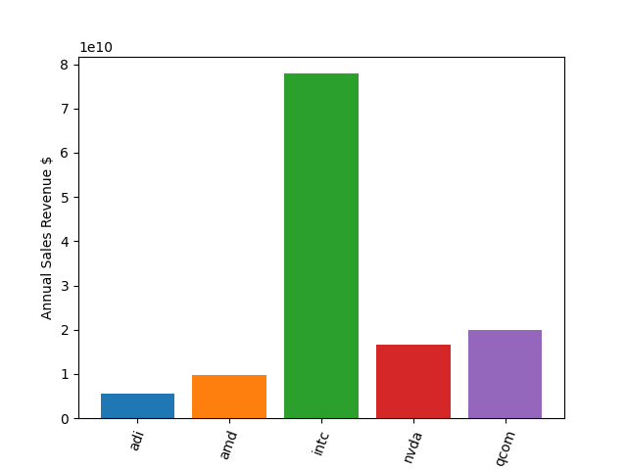
Intel appears to dominate the chip market, based on my sample of 5 companies
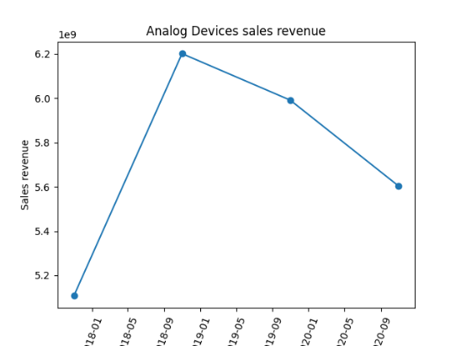
Let’s look at the sales growth trends for the 5 companies

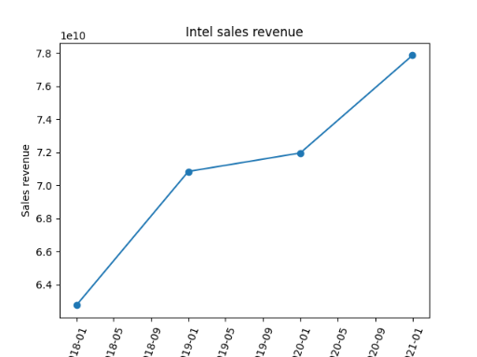
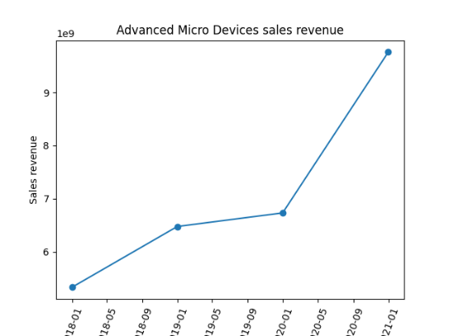

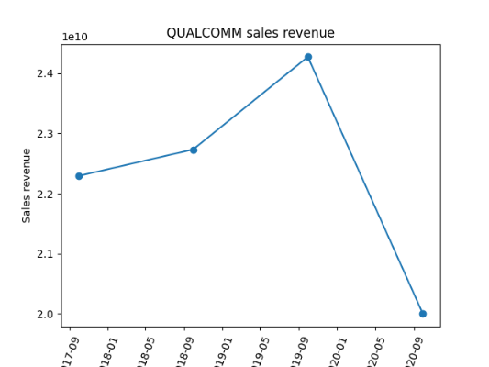
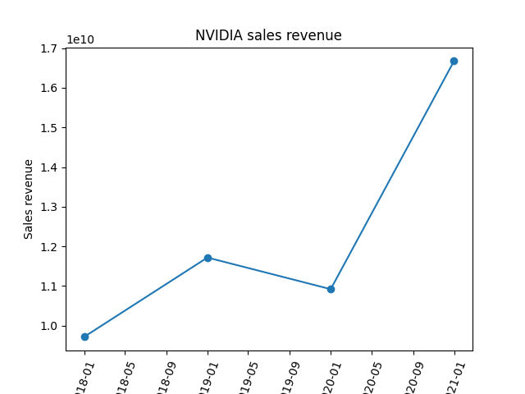
Analog have had 2 years of declining sales, QUALCOMM are down in 2020, I will eliminate them from the watchlist, as AMD, INTEL and NVIDIA are better prospects based on sales trends.
Visualizing Earnings per Share performance for AMD, INTEL and NVIDIA

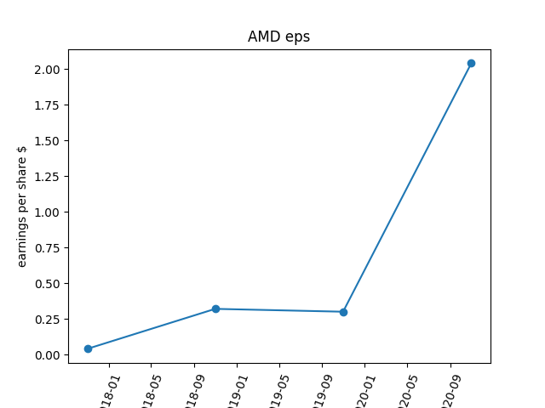
Revenue from Sales is the top line
Earnings per share is the bottom line where the net profit per share is called earnings per share.
AMDs strong sales revenue performance in 2020 has worked down to the bottom line, with a huge increase in earnings per share.
Is this growth sustainable?

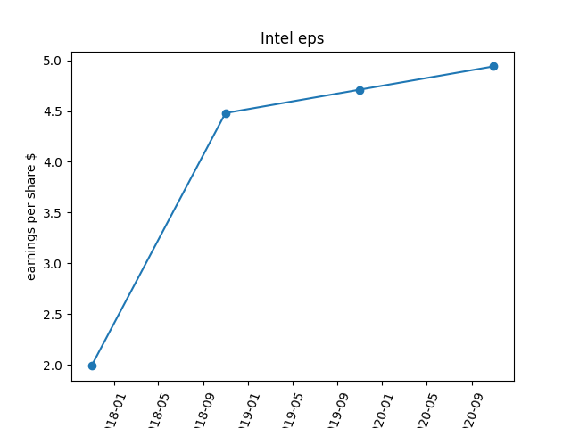
The same curious quantum jump in earnings per share, this time INTEL in 2018, more than doubling.
Earnings growth in 2019 and 2018 show steady slower rate of growth.

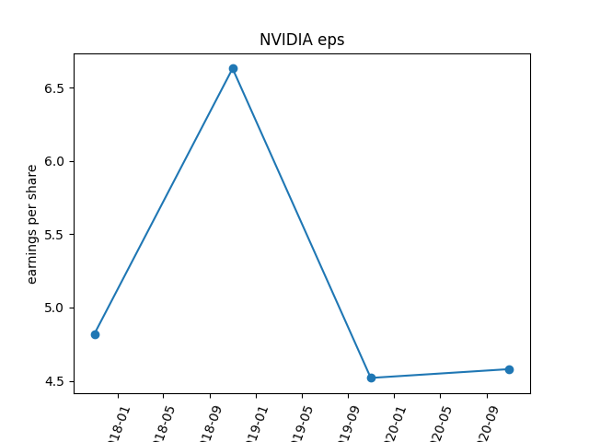
While NVIDA sales have grown impressively in 2020, the additional revenue has not made it to the bottom line
2018 looks like an outlier
This eps behaviour is inconsistent, and finding the causes of this would be critical for putting a fair value on this stock

Overall, there is a lot of volatility in eps, more than I would have expected in a relatively mature technology sector. More investigation into the nuts and bolts of each company is warranted before I would put a valuation on each stock.

5.0 Insights from the Visualisations

- The plots communicate the data so much better than tables of numbers; this is my first deep dive into fundamental analysis, and I am impressed with the far superior power of a plot to communicate clearly and effectively. This insight alone is worth the time and effort.

- The measures of growth from the subject 5 stocks show unexpected volatility, jumps and plunges. Investors like consistency not volatility. Perhaps the chip business cycle and product cycles are not suited to neat annual time periods.

- Deriving an accurate estimate for growth from the model is not possible, there is too much volatility. Plugging in an estimate of growth into the stock valuation formula using this data alone is dangerous. The stock valuation formula is very sensitive to the growth estimate. Further due diligence is required into the semi-conductor market and into each company of interest to get a more holistic prediction of growth.

- Intel tower over the other players in market capitalisation, market share and revenue, Intel’s growth data does correlate with Intel’s current delays and challenges with developing and producing their next generation chip. The market is growing, but Intel are losing market share to AMD who can match INTEL on their current chip’s performance.

- Combining market intelligence with fundamental valuation is a solid strategy for investment decisions. Real investment decisions require validated and tested valuation models. I view this project model as a prototype.

Appendix 1 – Method for calculation of intrinsic value of a stock

